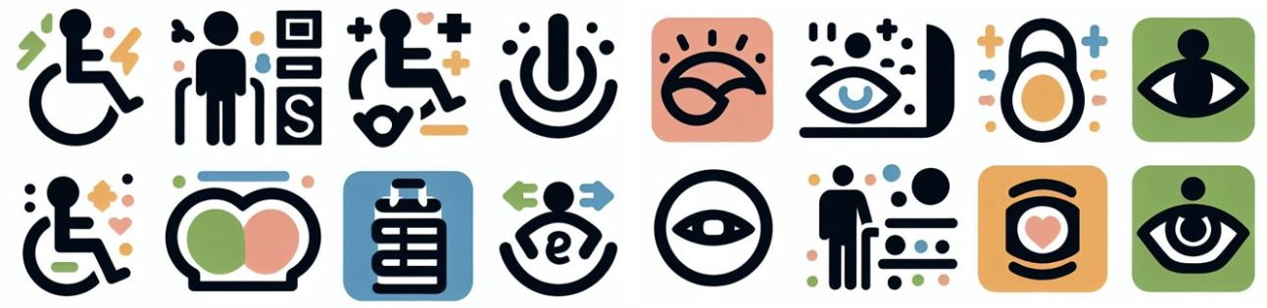
Infopack
Inclusive Library Services
Practical guide to resources, services, and spaces for an inclusive experience.

The document complies with the guidelines for creating accessible documents.
To listen to the document, click on "Review" and select "Read Aloud." To stop the reading, click on "Pause." The "Read Aloud" option is available for Office 2019, Office 2021, and Microsoft 365.

Summary
1. Services 3
1.1 Bibliographic assistance 3
1.2 Request book or journal article 3
1.3 Borrowing and reserving 3
1.4 Convert documents into accessible formats 3
1.5 Accessible workstation 4
1.6 Solutions for independent mobility and environmental adaptation 4
2. Useful links and contacts 5

- Services
The Library's inclusion services are available Monday through Friday from 8:30 AM to 1:00 PM and from 2:00 PM to 5:30 PM.
  - Bibliographic assistance
What is it?
Support for bibliographic research on specific topics.
How do I access the service?
Fill out the online form with the keywords for your research.
How do I access the form?
Sign in with your Luiss account.
Link to access the online form: http://static.luiss.it/biblioteca-studenti-dottorandi/
  - Request book or journal article
What is it?
Receive instructions for accessing e-books and e-journals on the Library’s digital platforms.
Get PDF with OCR (Optical Character Recognition) of books and journal articles available in the Library only in print format.
How do I access the service?
Fill out the online form with the bibliographic references of the book or journal article.
How do I access the form?
Sign in with your Luiss account.
Link to access the online form: http://static.luiss.it/biblioteca-studenti-dottorandi/
  - Borrowing and reserving
What is it?
Reserve a library book and pick it up in person or through a delegate.
How do I access the service?
Send an email to bibliotecainclusione@luiss.it with the bibliographic references.
  - Convert documents into accessible formats
What is it?
Convert documents, images, and web pages into alternative multimedia and accessible formats.
How do I access the service?
Use the SensusAccess online platform in self-service: https://biblioteca.luiss.it/en/accessibility-tools
How do I convert a document?
Upload the original file; select the format you wish to have converted; enter your Luiss email and send the request.

  - Accessible workstation
In the Periodicals Room are available: a height-adjustable table with an armrest support, a video magnifier with voice synthesis and OCR (Optical Character Recognition), and a trackball mouse.
The ergonomic workstation and video magnifier are freely accessible from Monday to Sunday from 8:30 AM to 9:00 PM.
To use the video magnifier and request the trackball mouse, contact the library staff or send an email to bibliotecainclusione@luiss.it.
  - Solutions for independent mobility and environmental adaptation
Reserved parking; accessible restrooms; access ramps; audio-tactile guiding path with smart canes; tactile maps.
To reserve the smart canes, send an email to bibliotecainclusione@luiss.it.
- Useful links and contacts
Webpage
https://biblioteca.luiss.it/en/inclusive-services
E-mail
bibliotecainclusione@luiss.it
Phone
0685225600
Online form
http://static.luiss.it/biblioteca-studenti-dottorandi/
Luiss Library Discovery (catalog)
https://luiss.summon.serialssolutions.com/en/#!/
Digital platforms with inclusive reading experience
https://biblioteca.luiss.it/en/electronic-resources?field_tags_target_id%5B112%5D=112&keys=

Luiss
Library | Inclusive Services

Via di Santa Costanza, 53
00198 Roma
T +39 06 85225600
bibliotecainclusione@luiss.it

